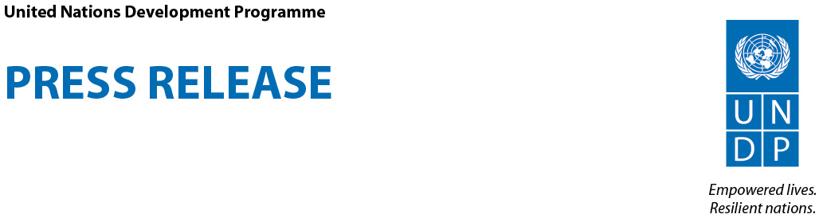

UNDP Launches Collection of Innovative Development Stories in Europe and Central Asia

New York, 5 September 2012—The United Nations Development Programme (UNDP) launched today a new publication at its Executive Board meeting showcasing transformative development achievements in Eastern European and Central Asian countries. Much of these successes are based on innovative new social policies addressing the needs of that region’s chronically poor and marginalized, including the Roma, youth, the long-term unemployed and people with disabilities.

The publication, Empowering Lives, Building Resilience, provides vivid examples of “triple-win” strategies that aim to advance social, economic and environmental objectives simultaneously. As a result of these often innovative strategies, UNDP – always in partnership with governments, the private sector and civil society – has helped to create jobs, meet the needs of the most vulnerable, manage the environment responsibly and provide for the prevention of and recovery from crisis and disaster.

“There are common qualities to transformational change, regardless of the context or country in which it takes place,” said Helen Clark, who heads UNDP. “Some critical characteristics of successful transformational change include measurable results, strong partnerships with governments and civil society and improved national capacity to manage development projects autonomously.”

Despite the relatively high average income in many of the region’s countries, large numbers of people are poor or at the risk of falling into poverty. Growing inequalities, due to social, economic and political exclusion, remain a challenge. Environmental degradation, especially the high rates of greenhouse gas emissions in some countries of Eastern Europe and Central Asia, poses additional threats to development.

“Each story documents how UNDP responds to the demands of governments in Europe and Central Asia, delivering sophisticated policy support that mitigates the impact of economic and environmental shocks that have the potential to push populations back into poverty,” said Cihan Sultanoglu, Director of UNDP’s Bureau for Europe and the Commonwealth Independent States.

Some highlights from the publication:
- A joint UN programme – with UNDP as one of its five partners – helped set up 16 jobs centres in Bosnia and Herzegovina, where currently 60 percent of young people cannot find jobs in that country. The centres provided career counseling and skills training to more than 6,800 young people within the first 14 months of operation; and its Facebook page had 11 million hits in its first year.
- UNDP partnered with the Global Environment Facility in Tajikistan to place management of natural resources in the hands of the people who actually use them; as a result, a community forestry management committee has overseen a 90 percent decline in tree cutting within an endangered tugai forest, a unique desert flood-plain forest found only in Central Asia.
- In Moldova, UNDP is helping 60 villages in 12 districts to convert heating systems in public institutions and residences to use biomass, made from readily available agricultural wastes; the switch has led to a profitable industry in biomass fuel making.
- A decade ago, UNDP brought in international expertise to help Armenia – one of the 60 most disaster-prone countries in the world – to develop a national disaster risk reduction system.
- In Kosovo, Montenegro and Serbia, UNDP has helped over 34,000 Roma and their families to access health care and other social services thanks to a programme that provides them with much-needed legal status. UNDP’s strategy included embedding Roma coordinators in local government institutions and assisting the Roma in organizing their own livelihood-improvement projects.

You can download the publication at: http://bit.ly/PTUjeJ

For more information about UNDP’s work in Europe and the CIS region, please visit http://europeandcis.undp.org/
For more information about UNDP Executive Board, click here.

#####

Media contact: Stanislav Saling, UNDP New York, Tel.: +1 212 906 5296, stanislav.saling@undp.org

UNDP partners with people at all levels of society to help build nations that can withstand crisis, and drive and sustain the kind of growth that improves the quality of life for everyone. On the ground in 177 countries and territories, the organization offers global perspective and local insight to help empower lives and build resilient nations. www.undp.org. Follow us on twitter and facebook.

http://www.undp.uz/projects/project.php?id=46
Referred to in the context of UN Security Council Resolution 1244 (1999)

